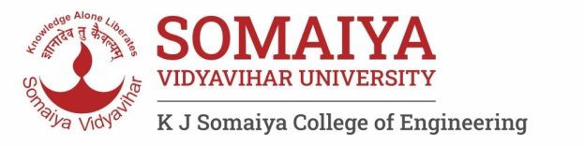Year : 2020-

**Department of Science and Humanities**

Engineering Chemistry Laboratory

List of Experiments (2021- 22)

|  |  |  |
| --- | --- | --- |
| **Sr. No.** | **Name of Experiments and link** | **CO Mapping** |
| 1 | To understand & familiarize with Good Laboratory Practices in Chemistry Laboratory | CO 1-5 |
| 2 | To understand the concept of pH indicator and to determine suitable indicator for acid-base titration. | CO-1 |
| 3 | To determine the hardness of water using EDTA titration. | CO-1 |
| 4. | To determine the chemical pollutants in water samples using advanced analytical techniques. | CO- 4 |
| 5 | Determine the viscosity average molecular weight of a polymer | CO-2 |
| 6 | To study the construction and working of compression molding. | CO-2 |
| 7 | To find out the unknown concentration of the sample and verification of Beer-Lambert's Law | CO-5 |
| 8 | To determine the available nitrogen in the soil sample by Kjeldahl Method | CO-3 |
| 9. | Interpretation of IR spectra | CO-5 |
| 10. | To measure the EMF of a cell and predict the spontaneity of the cell reaction | CO-3 |
| 11 | To determine the pH value of given solutions using pH meter. | CO-5 |
| 12 | To study the catalytic effect of finely divided particle | CO-4 |

Dr. Bharati Choudhari

**Lab In-charge**

**Engineering Chemistry Laboratory**